TASK:

Create a dashboard with 3 panels:

1. CI/CD Metrics Panel (DORA metrics + pipeline status)
2. Agile Development Panel (Sprint progress / velocity)
3. Security Panel (Vulnerabilities, scan results)

STEPS:

1. Added the infinity datasource from connection:

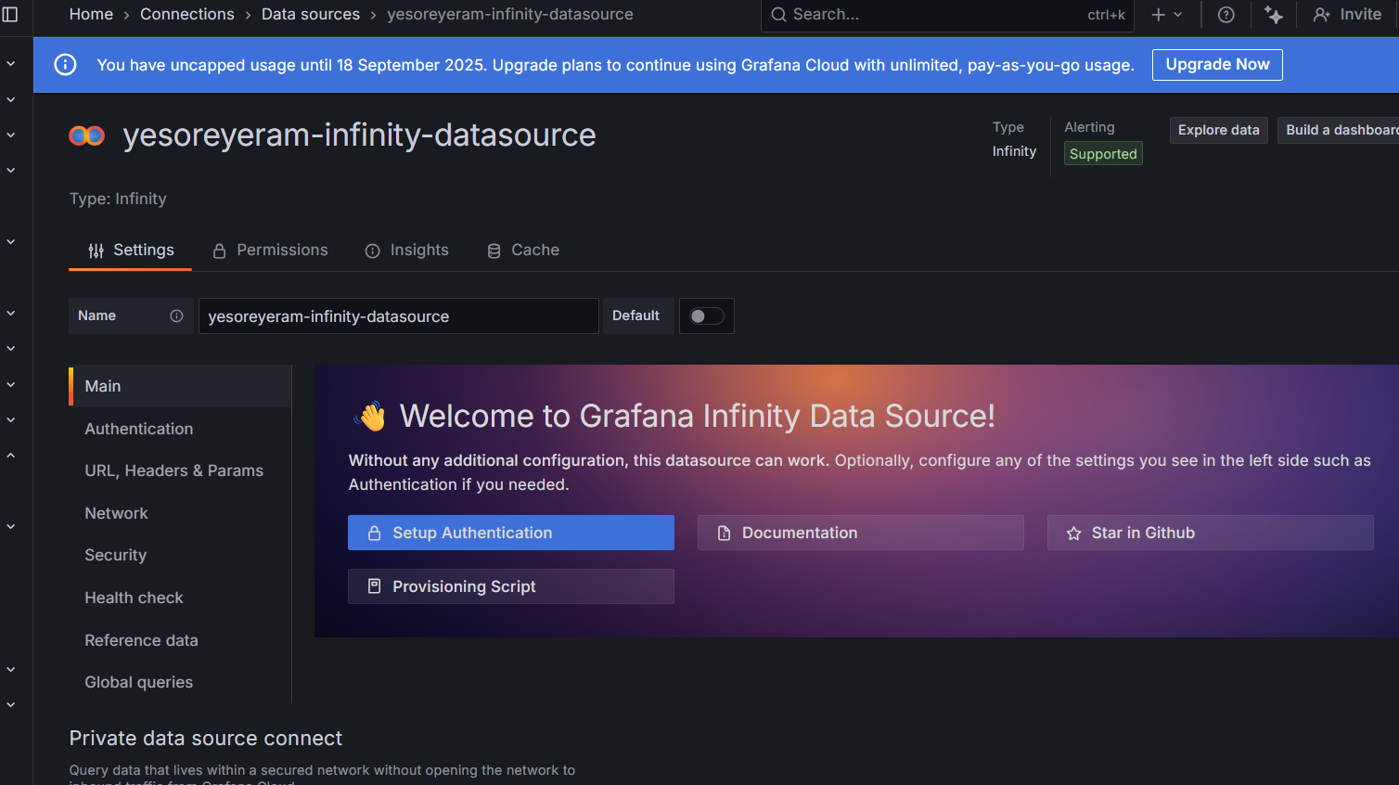

1. Creating 1st panel - CI/CD Metrics Panel (DORA Metrics + Pipeline Status)

Csv data:

timestamp,deploy_frequency,lead_time,change_failure_rate,mean_time_to_recover

2025-09-01T00:00:00,5,1.5,0.1,1

2025-09-02T00:00:00,4,2,0.15,2

2025-09-03T00:00:00,6,1.2,0.08,0.8

2025-09-04T00:00:00,7,1.0,0.05,0.5

2025-09-05T00:00:00,5,1.8,0.12,1.2

Screenshots:

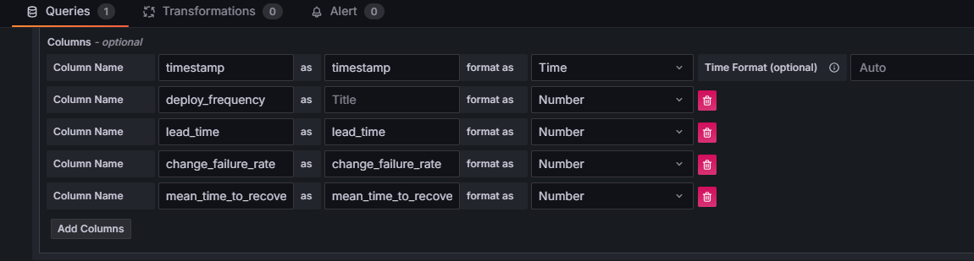

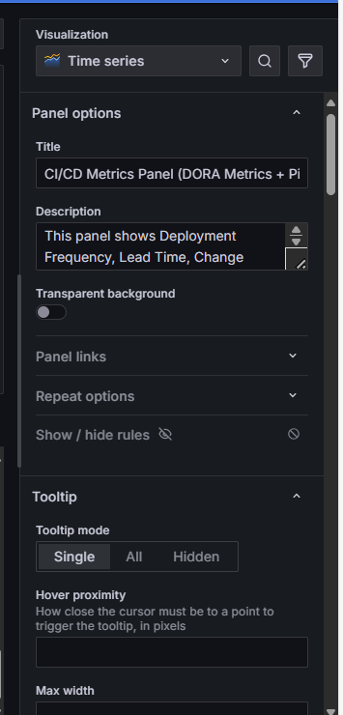

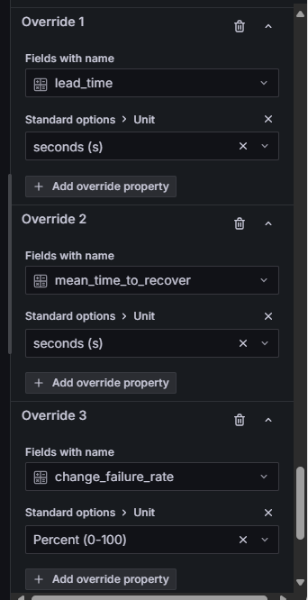

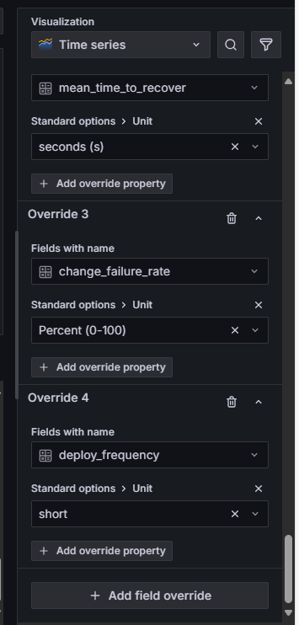

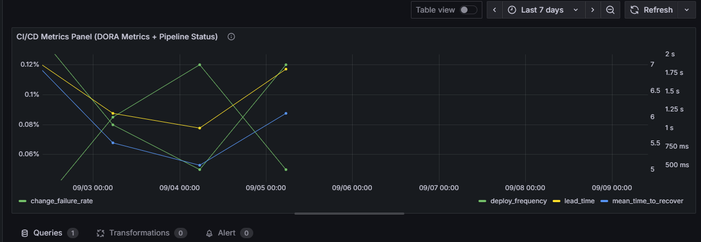

1. Creating 2nd panel - Agile Development Panel (Sprint / Velocity)

Csv data:

sprint,committed_story_points,completed_story_points,sprint_end_date

Sprint 1,50,45,2025-09-07

Sprint 2,55,53,2025-09-14

Sprint 3,60,58,2025-09-21

Sprint 4,65,62,2025-09-28

Screenshots:

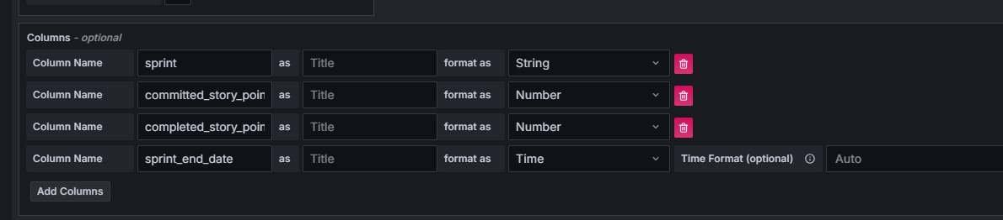

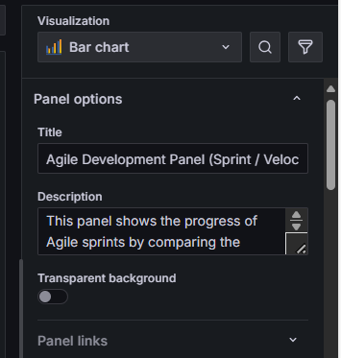

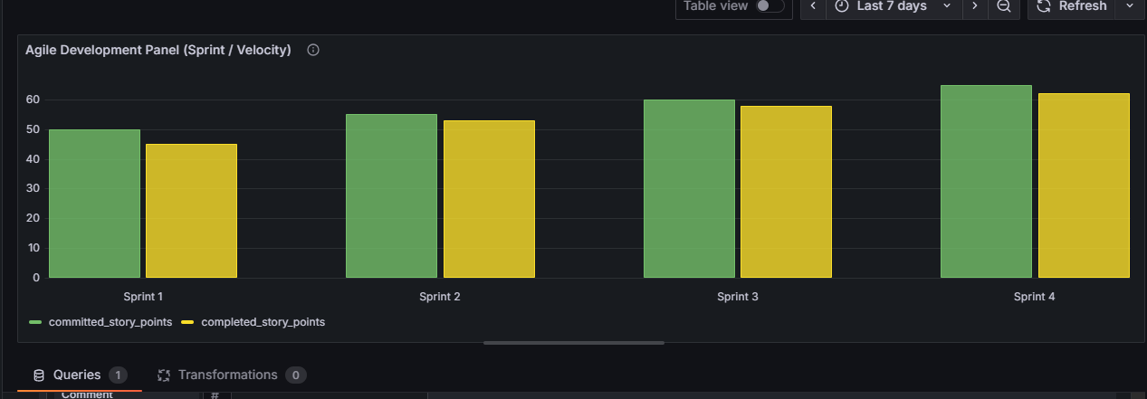

1. Creating 3rd panel - Security Panel (Vulnerabilities over Time)

Csv data:

timestamp,critical,high,medium,low

2025-09-01T00:00:00,5,10,20,50

2025-09-02T00:00:00,4,12,18,48

2025-09-03T00:00:00,3,8,15,40

2025-09-04T00:00:00,2,5,12,35

2025-09-05T00:00:00,1,3,10,30

Screenshots:

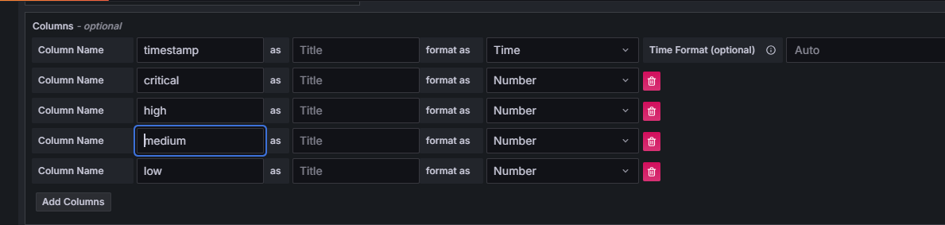

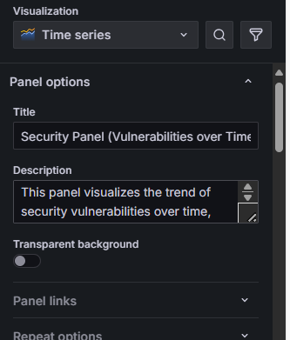

Changed field names:

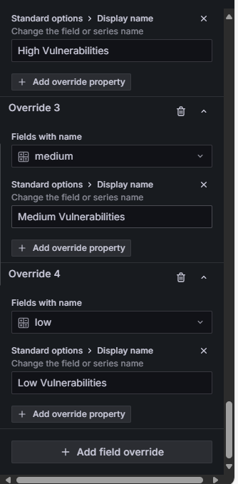

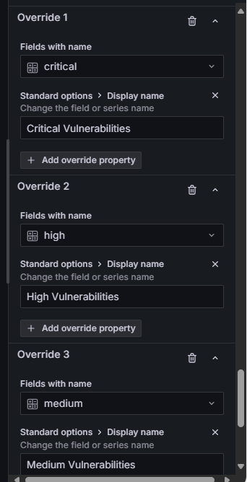

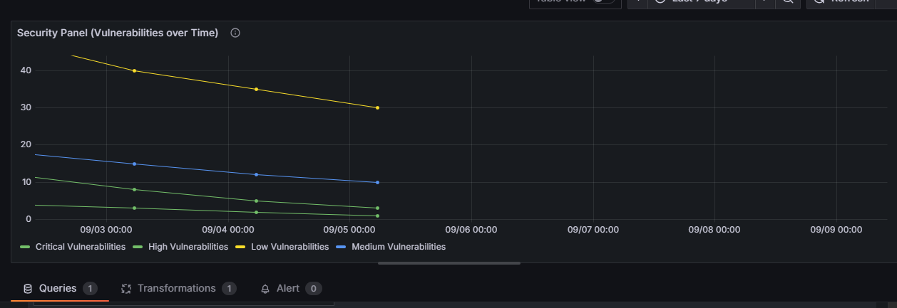

1. Added 4th Panel - SDLC panel

Visualization Type : Text

Content:

<div style="color: black; background-color: white; padding: 10px; text-align: center; border-bottom: 2px solid #E0E0E0;">

<h1>Software Development Lifecycle Metrics</h1>

</div>

Screenshots:

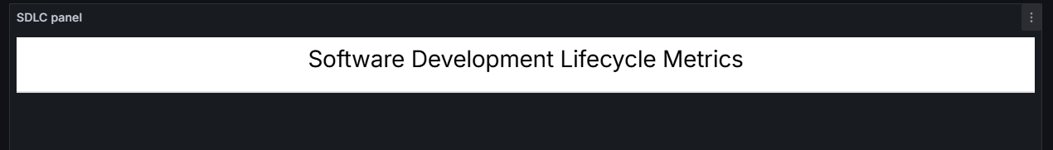

1. Rearranged all the panels and the last dashboard is:

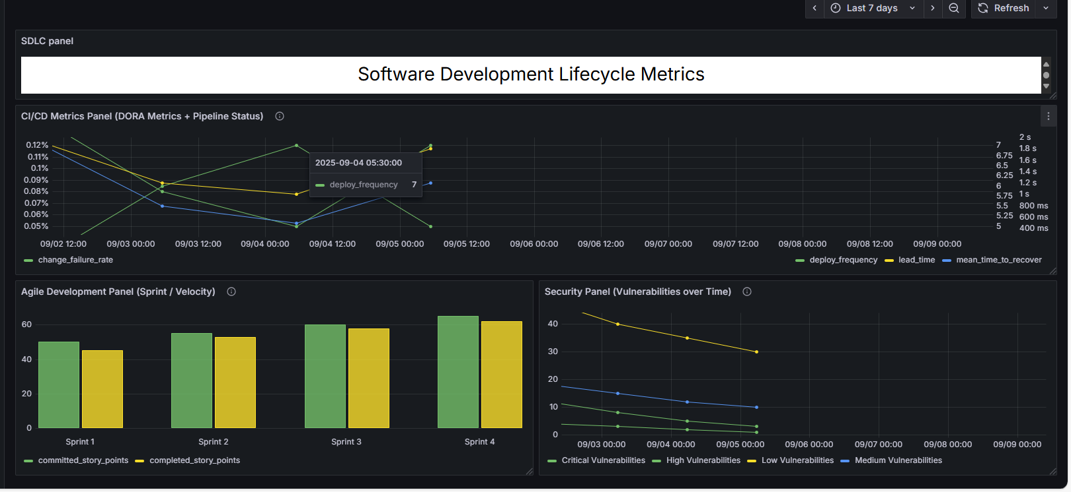

1. Taking Backup of this DashBoard:

Export button on the top of the Dashboard:

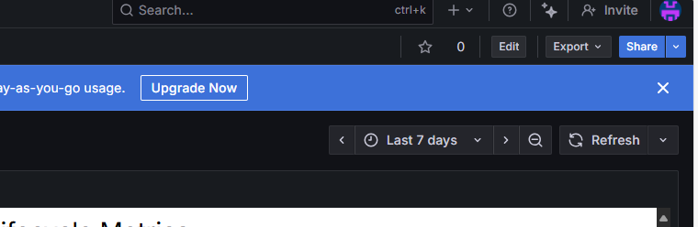

Export as code:

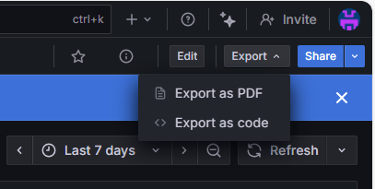

**Download file:**

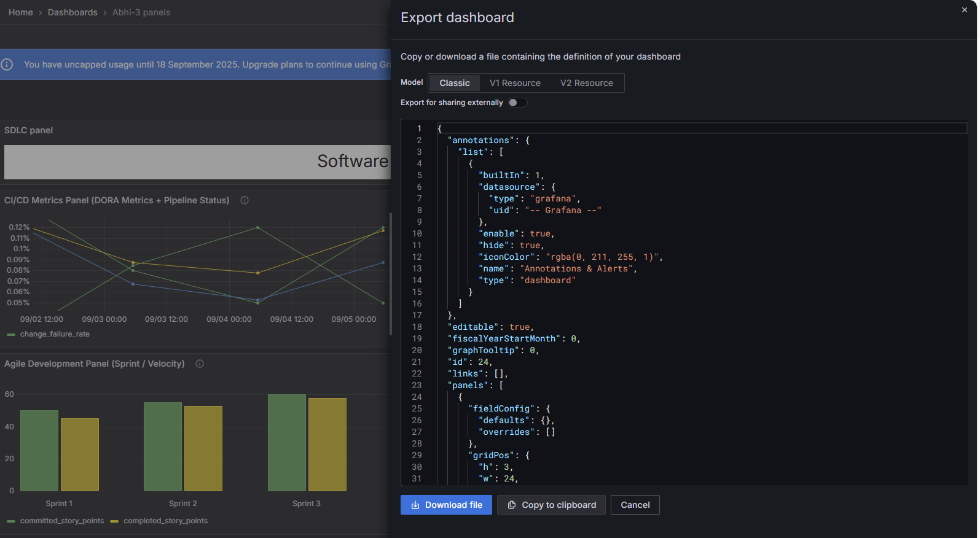

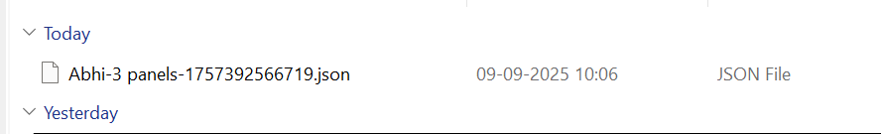

1. Configured Alert Rule for CICD Panel:

Screenshots:

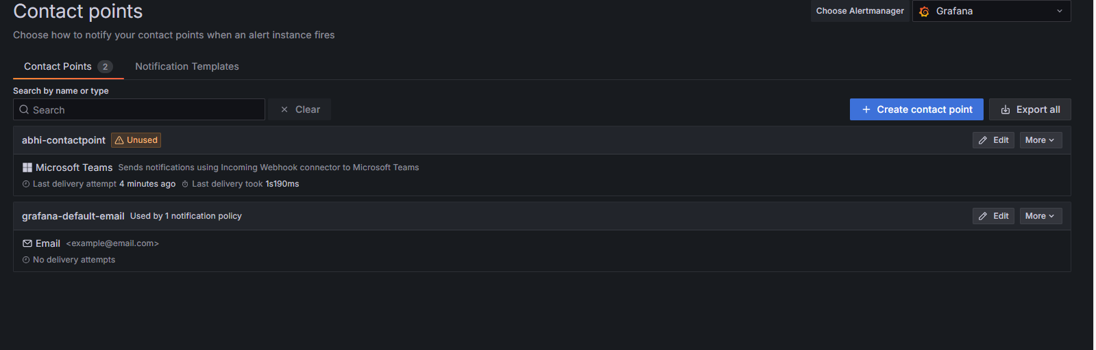

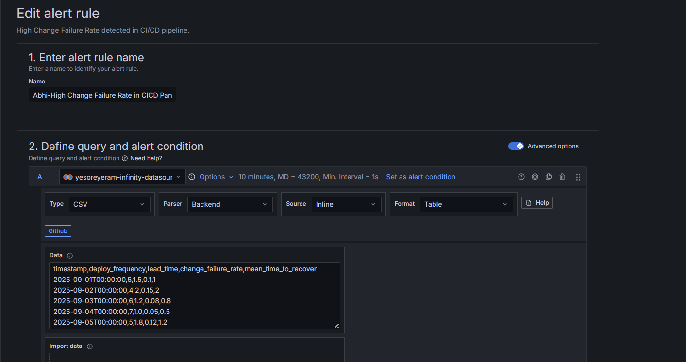

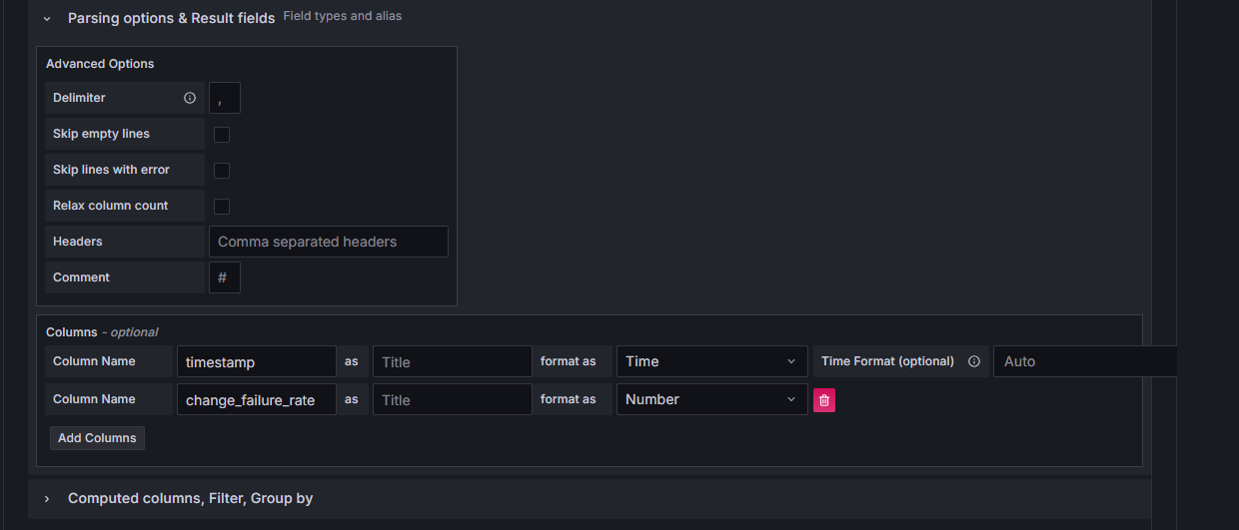

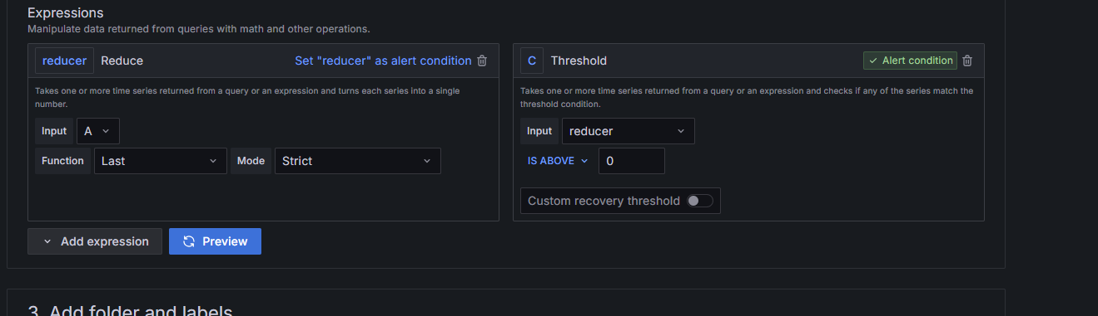

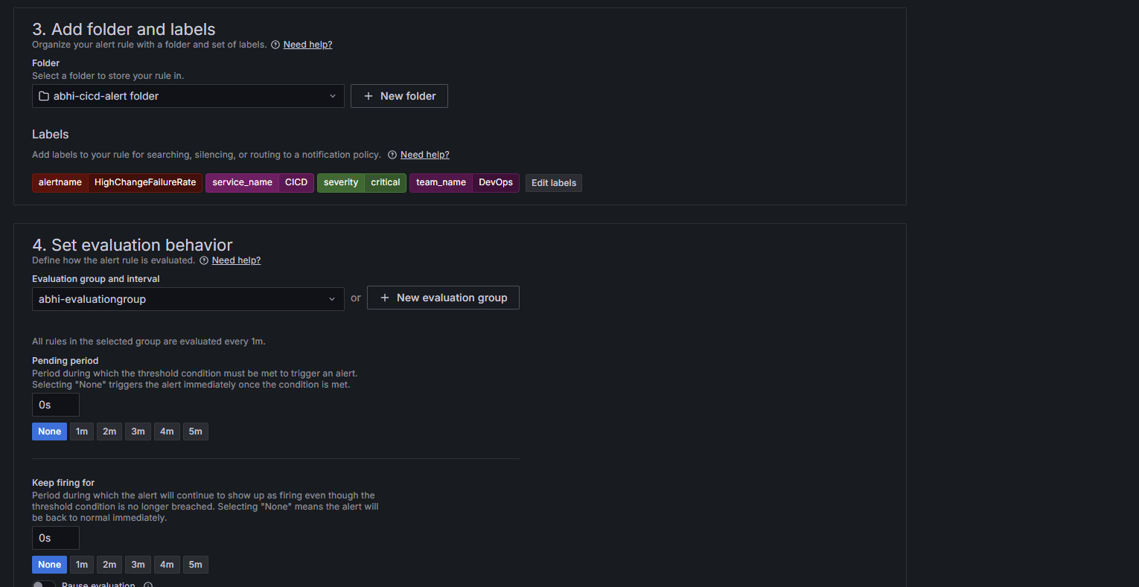

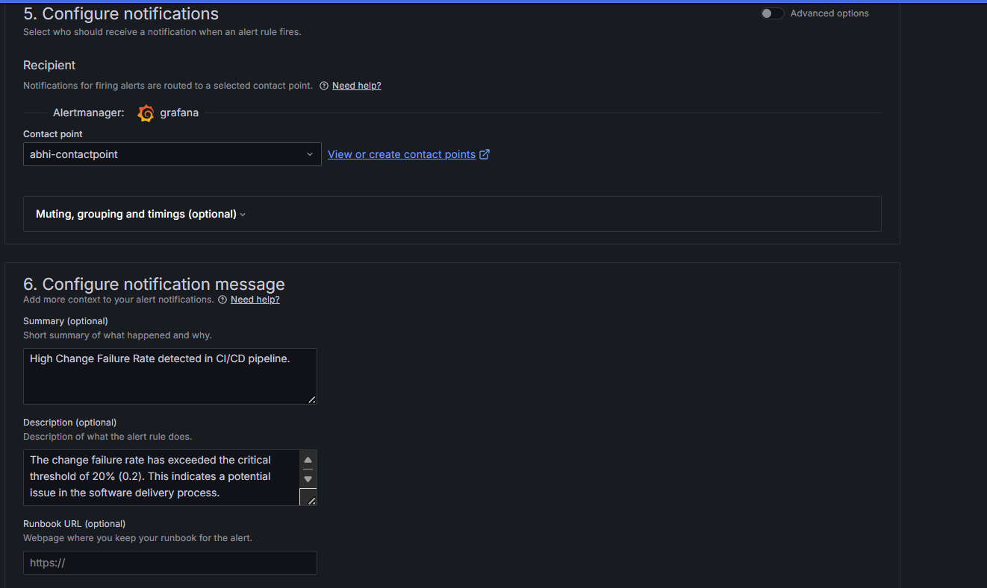

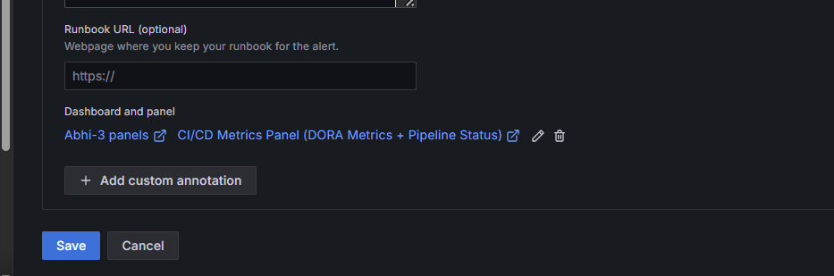

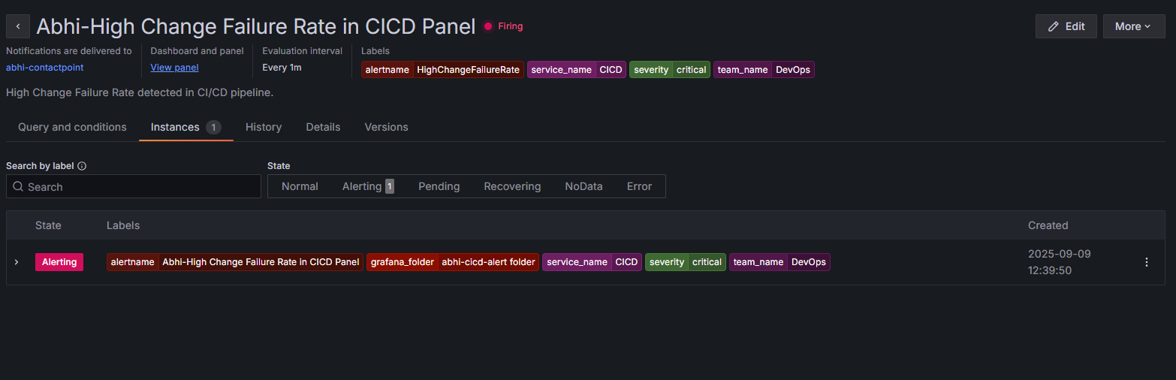

RESULT SCREENSHOT IN TEAMS:

